EU Declaration of Conformity (DOC)
We
Company Name | Twelve South LLC
Company Address | 1503 King Street, STE201, Charleston, SC 29405, USA

declare that this Declaration of Conformity is issued under our sole responsibility and belongs to the following product/s:

Product Name | Product Code/s
Power supply (wireless) | PowerBug EU (Slate) TS-2544
Power supply (wireless) | PowerBug EU (White/Dune) TS-2545

The object of the declaration described above is in conformity with the relevant designated legislation:
LVD Directive 2014/35/EU
RED Directive 2014/53/EU
EMC Directive 2014/30/EU
ERP Directive 2009/125/EC
The Product/s described above is/are in conformity with the relevant Union harmonisation legislation below:
Standard/s
ETSI EN 300 330 V2.1.1 (2017-02)  ETSI EN 301 489-1 V2.2.3 (2019-11)  ETSI EN 303 417 V1.1.1 (2017-09)  ETSI EN 301 489-3 V2.3.2 (2023-01)  EN 50665:2017  EN IEC 62311:2020 | EN 55032:2015+A11:2020 +A1:2020  EN 55035:2017+A11:2020  EN IEC 61000-3-2:2019+A1:2021 +A2:2024  EN IEC 61000-3-3:2019+A1:2021
EN IEC 62368-1:2020+A11:2020

Object of the declaration (Identification of product)
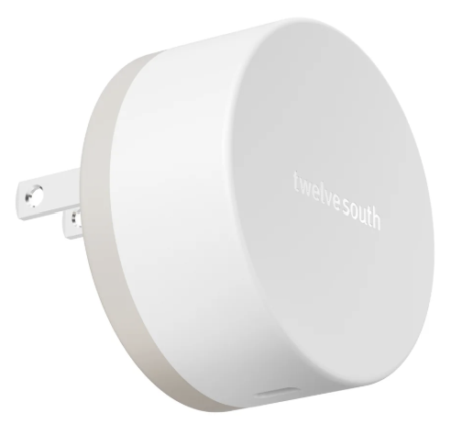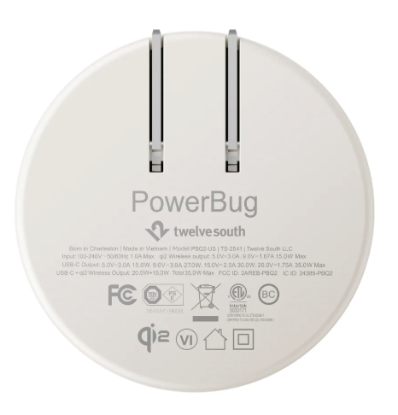

Notified Body (Where Applicable): | Reference Number of the certificate of notified body:
Additional Information:
Signature:  | Signed for and on behalf of:  Twelve South, LLC
Name: Kelly Witte | Position: VP,Global Product Development
Place of Issue: Charleston, SC 29405,USA | Date of Issue: 03/21/2025

