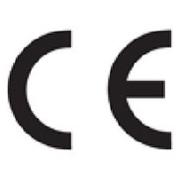
Declaration of Conformity

Manufacturer: Sandberg A/S

Address: Bregneroedvej 133D, 3460 Birkeroed, Denmark

Product description: Bluetooth headset with charging dock

Product name/Type no: Sandberg Bluetooth Headset ANC+ENC Pro/ 126-45

We declare under our sole responsibility that the products, to which this declaration relates, are in conformity with the Council Directives on the approximation of the laws of the EEC Member States relating to the following:

Directives
EMC Directive 2014/30/EU
RED Directive 2014/53/EU
RoHS Directive 2011/65/EU with amendment (EU)2015/863：

And standards

ETSI EN 300 328 V2.2.2（2019-07）
ETSI EN 301 489-1 V2.2.3（2019-11）
EN 301 489-17 V3.2.4（2020-09）
EN 55032:2015+A1:2020
EN 55035:2017+A11:2020
EN IEC 61000-3-2:2019+A1:2021
EN 61000-3-3:2013+A2:2021
EN 62479:2010
EN 50663:2017
EN IEC 62368-1:2020+A11:2020
IEC 62321-3-1:2013
IEC 62321-4:2017
IEC62321-5:2013
IEC62321-6:2015
IEC62321-7-1:2015
IEC62321-7-2:2017
IEC62321-8-2017

Date: 27th October 2023 Location: Birkeroed, Denmark

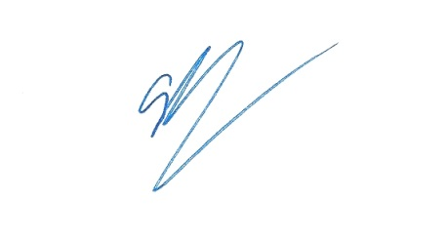
Name: Anders Petersen
_____________________________
Signature

