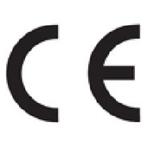

Declaration of Conformity

Manufacturer: Sandberg A/S

Address: Bregneroedvej 133D, 3460 Birkeroed, Denmark

Product description: Bluetooth headset

Product name/Type no: Sandberg Bluetooth Headset ANC+ENC 126-44

We declare under our sole responsibility that the products, to which this declaration relates, are in conformity with the Council Directives on the approximation of the laws of the EEC Member States relating to the following:

EMC Directive 2014/30/EU
RED Directive 2014/53/EU
RoHS Directive 2011/65/EU with amendment (EU)2015/863

Following standards were applied :

EMC : EN 55032 :2015/A11 :2020
EN IEC 61000-3-2:2019
EN61000-3-3:2013/A1:2019
EN55035:2017/A11:2020

RED : EN 62479 :2010
EN 50663 :2017
EN IEC 62368-1 :2020+A11 :2020
EN 50332-2 :2013
ETSI EN 301 489-1 V2.2.3 (2019-11)
ETSI EN 301 489-17 V3.2.4 (2020-09)
ETSI EN 300 328 V2.2.2 (2019-07)

RoHS: IEC 62321-3-1:2013
IEC 62321-4:2013+A1:2017
IEC 62321-5:2013
IEC 62321-6:2015
IEC 62321-7-1:2015
IEC 62321-7-2:2017
IEC 62321-8-2017

Date: 10. July 2023 Location: Birkeroed, Denmark

Name: Anders Petersen
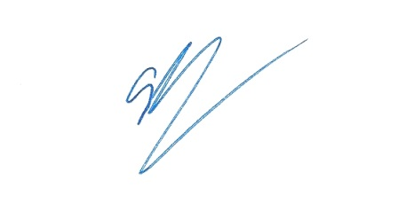
Brand Director

_____________________________
Signature

